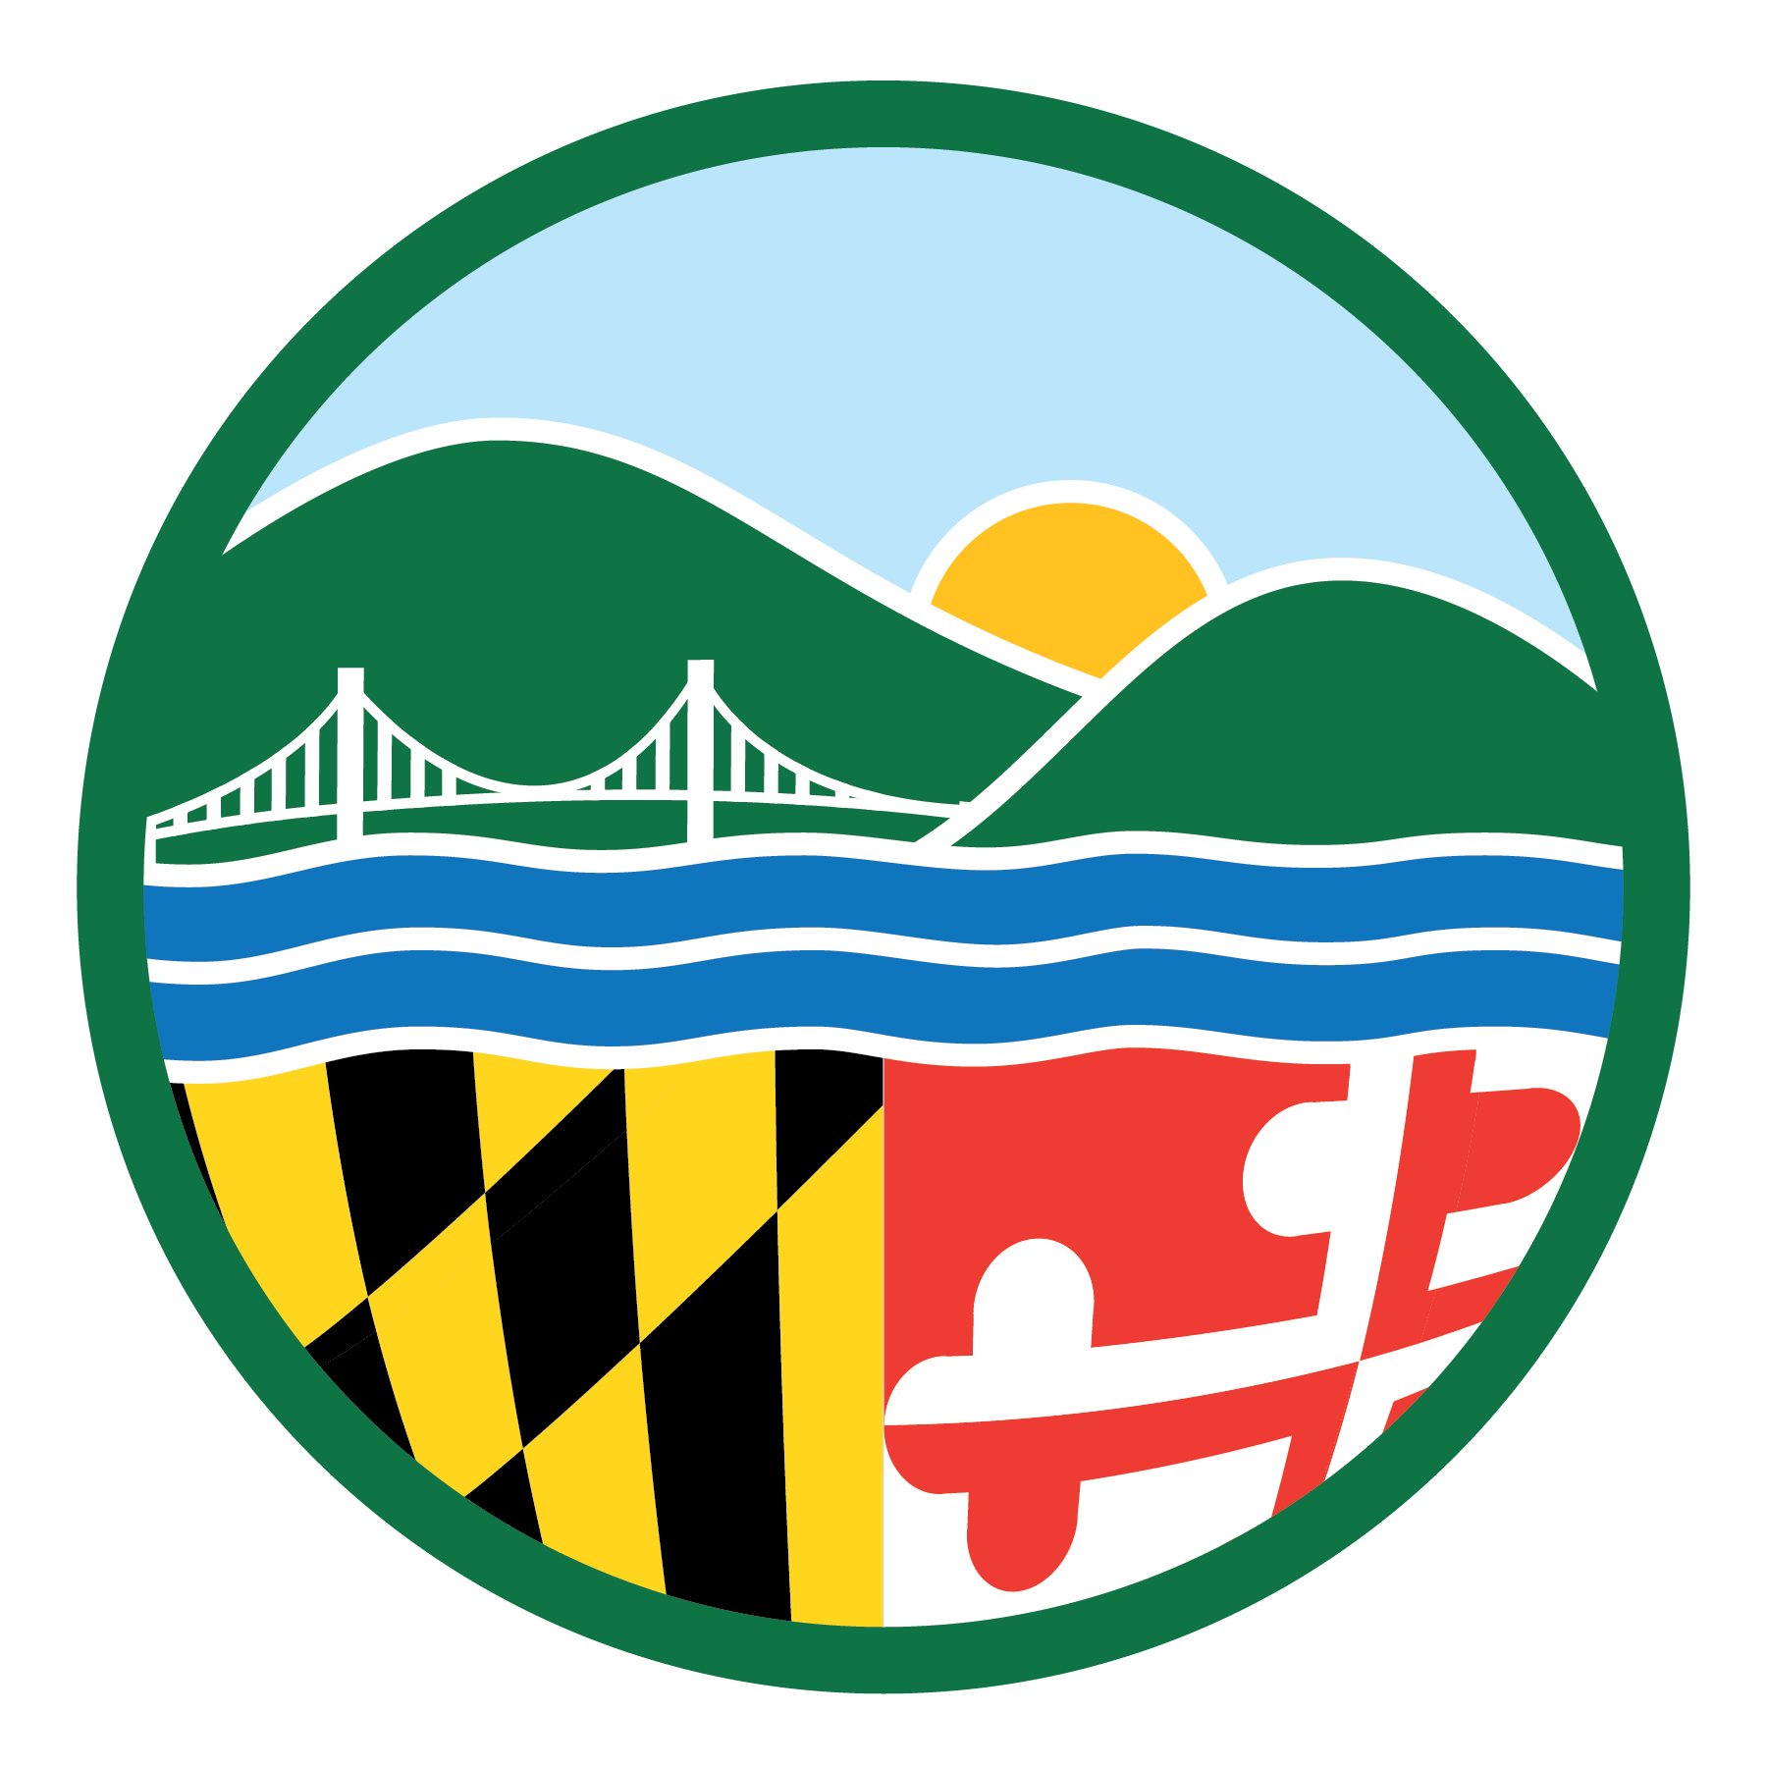PUBLIC MEETING ANNOUNCEMENT FOR MDE WEB PAGE

Instructions:
- Using the drop down lists and text boxes, please complete the form below with the requested information. Once the form is completed, please save the form as “Public Meeting Announcement – [Insert Site Name]”.
- Go to “File” and select the “Send To” option. A new drop down menu will appear to the right with the words “Mail Recipient (as attachment). Select this option.
- Submit a request to the DOit Service Desk (Service.Desk@maryland.gov) requesting that a work ticket be opened to allow the announcement to be posted on the MDE website.
- Email the document to Mark Shaffer and copy Carrie DeBoy, Fiona Hinman, Ann Goddard, Jamie Alther and Barbara Krupiarz.
- To ensure that the meeting announcement is posted on the website in a timely manner, please send this notice at least two weeks in advance of the public meeting.

FROM: | Linda Gustafson
TO: | Mark Shaffer
CC: | Carrie DeBoy  Fiona Hinman  DOit Service Desk | Ann Goddard  Jamie Alther  Barbara Krupiarz

Administration: | Land Management Administration
Date: | 04/28/2022
Time: | 7:00 PM
Location: | Ramada Conference Center, 1700 Van Bibber Road, Edgewood, Maryland
Subject: | Title: U.S. Army Aberdeen Proving Ground Restoration Advisory Board Meeting  Topics: 1) Public Meeting: Fort Hoyle Proposed Plan, 2) Lauderick Creek Data Report, and 3) APG LTM Update
Contact: | Linda Gustafson, 410-537-4238

